Bryan Pincock
Prof. Collin Hull
ENGL 2010 – 030

Report
Overview
Taxation on cigarettes has been around since the 19th century, generally introduced when the country was in need of money. In the early 20th century the federal government instituted an excise tax on cigarettes. This tax was originally designed to help cover the cost for transporting the product across the country, and would increase the further consumers live from the center of production. (Benjamin and Dougan)
In 2010 the smokers throughout the United States experienced the largest single excise tax increase to their cigarettes. According to the Federation of Tax Administrators, a group of tax administrators that advise state tax authorities, the median U.S. sales tax on a pack of cigarettes is $1.25, which is a 34.72% increase over the tax from 2009. Missouri has the lowest at $0.17 for a 4.72% increase and New York has the highest at $4.35 for a 120.83% increase. Utah’s sales tax on cigarettes is at $1.70, which amounts to a 47.22% increase from 2009.
Compare this to the sales tax on items such as fast food and soda during the same time frame and using the average price of one pack of pre-tax cigarettes as our guideline, which is approximately $3.60. The U.S. median tax on these other items is $0.18 for a 4.97% increase, Missouri at $0.15 for a 4.225% increase, New York at $0.14 for a 4% increase, and Utah at $0.21 for a 5.95% increase. (FTA Home Page, Tax Rates)

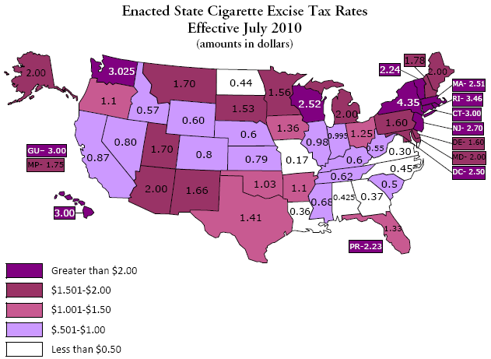
Photo courtesy of http://www.ncsl.org/issues-research/health/2010-state-cigarette-excise-taxes.aspx

Proponents
Lawmakers have given three reasons for this large tax increase. 1) To make it financially beneficial to quit smoking. 2) To fund cessation programs to help smokers quit and introduce youth to the dangers of smoking in an effort to prevent them from ever starting. 3) To subsidize governmental health care programs such as Medicaid, to help pay for the high cost of treating the health problems associated with smoking.
The first reason for the increase of excise taxes on cigarettes is to reduce the number of smokers by making them pay more money for cigarettes. (Heen). If we look at Utah’s revenue from the tobacco excise tax, we can see that in 2003 the state had a $0.70 excise tax per pack of cigarettes which created $38.1 million in revenue. This equates to 54.4 million packs of cigarettes sold. In 2010 the tax increased to $1.70 excise tax per pack of cigarettes. The increase resulted in $58.4 million in revenue, or 34.4 million packs of cigarettes. This data proves that the increase is working to reduce smoking. (United States).
The second reason was to help fund cessation programs and create awareness among our youth to the dangers of smoking. The Center for Disease Control, or CDC, has submitted a report that shows with the proper funding for these programs, reduction in smoking throughout all age groups will decrease by 17% in three years. Increasing the excise tax on cigarettes is a great method for acquiring the funding required for these programs. (United States).
The third reason is to help pay for the long term health costs associated with smoking. By placing an additional tax on cigarettes the states can subsidize programs such as Medicaid and Medicare. This extra funding will help pay for those high costs.
Opposition
Most smokers would agree that smoking is not healthy and would like to get assistance to quit. Increasing the amount they would pay for cigarettes is not the answer.
Scientist and senior director of RTI's Public Health Policy Research Program and Matthew Farrelly, Ph.D., has studied the effects of the cigarette tax and explains, excise taxes are effective in changing smokers' behavior, but not all smokers are able to quit, and low-income smokers are disproportionately burdened by these taxes. (Farrelly).
Looking at the yearly State Revenue Report from the Internal Revenue Service, we can see a reduction in some states of cigarette sales from 1993 to the sales in 2011, (after the large increase to the cigarette excise tax). We can also see a dramatic rise in cigarette sales in neighboring states. Although Utah saw a reduction in cigarette sales of twenty million packs, the neighboring states of Idaho and Wyoming saw an increase of almost sixteen million and thirty five million packs respectively. (United States). This actually suggests that smoking is not decreasing, smokers are simply traveling to other states to purchase their cigarettes.

The argument that the money will be used to support programs to educate the youth to the dangers of smoking and cessation programs for current smokers can also be argued. The Center for Disease Control, or CDC, has suggested that states should be spending $3.7 billion on tobacco control programs to help prevent smoking. To date, the average amount spent on these programs is only $641 million. That is merely 17.3% of the CDC’s recommendation. (United States).
In 2010 Utah made $90.4 million in tobacco revenue. However, it only spent $7.4 million on these programs. These funds are being used for things like advertising the downsides of smoking, smoking cessation programs, and helping to fund children’s health programs. This is still only 35.2% of the CDC’s annual recommendation. (United States).
Opposition can also question the argument of funding Medicaid and Medicare. Although the IRS shows that $641 million is being used for cessation and prevention programs, it does not show where the remaining revenue is being used. In 2010 Utah used $7.4 million on these programs, the remaining $83 million made in tobacco revenue was placed into the general fund and can now be used for any project that the state legislature chooses.
Conclusion
The tax on cigarettes will always be a contested. At what point is the government policing our morals? What can the government do, or should they do to protect Americans from themselves. Whatever side of this argument an individual may find themselves, there will always be someone on the other side with an opposing argument. Let us hope that a middle ground is found that will someday satisfy both parties.

Works Cited
"FTA Home Page, Tax Rates." FTA Home Page. Federation of Tax Administrators, 01 Jan. 2012
Farrelly, M.C., Nonnemaker, J.M., & Watson, K.A. The consequences of high cigarette excise taxes for low-income smokers. PLoS one. 2012. Web. 01 Oct. 2012
Siegel, Michael. "The Rest of the Story: Tobacco News Analysis and Commentary." : Use of Cigarette Tax Revenue from Increased State Excise Tax to Fund Critical Government Programs Appears to Be Major Theme in 2009. N.p., 05 Jan. 2005. Web. 04 Oct.
Heen, Mary L. “CONGRESS, PUBLIC VALUES, AND THE FINANCING OF PRIVATE CHOICE.” Ohio State Law Journal 65.853 (2004). Web. 01 Oct. 2012.
Benjamin, Daniel K. / William R. Dougan. “EFFICIENT EXCISE TAXATION: THE EVIDENCE FROM CIGARETTES” Journal of Law & Economics University of Chicago 40.113 (1997). Web. 01 Oct. 2012.
United States. Centers for Disease Control and Prevention. Morbidity and Mortality Weekly Report. May 25, 2010. Web. 09 Oct. 2012.

